NCGen Package and Jar Creation - RH1
Schindler CRD Applications

Exported on 2025-08-19 05:08:25

Table of Contents

1 3
2 Windchill OOTB Jars 4
3 Custom Properties file 6
4 Custom Jar creation 7
4.1 Input file for jar 7
4.2 wt.jar Creation 7
4.3 ptcms.jar Creation 9
4.4 windchill_properties.jar Creation 10
4.5 BAC.jar Creation 12
5 SSL Certificate 14
6 Share jar/Properties/Certificate with NCGen 15
7 Issues and Resolution 18
7.1 RMI issue over HTTP tunneling is not supported with this Java version 18
7.1.1 Issue : 18
7.1.2 Resolution : 18
7.2 WhereExpression Class not found exception while package compilation 19
7.2.1 Issue : 19
7.2.2 Resolution : 19
7.3 Getting Windchill Authentication pop-up while publishing jobs on NcGen Worker 19
7.3.1 Issue : 19
7.3.2 Resolution : 20

- Overview Windchill OOTB Jars Custom Properties file Custom Jar creation Input file for jar wt.jar Creation ptcms.jar Creation windchill_properties.jar Creation BAC.jar Creation SSL Certificate Share jar/Properties/Certificate with NCGen Issues and Resolution RMI issue over HTTP tunneling is not supported with this Java version Issue : Resolution : WhereExpression Class not found exception while package compilation Issue : Resolution : Getting Windchill Authentication pop-up while publishing jobs on NcGen Worker Issue : Resolution : Overview
- Windchill OOTB Jars
- Custom Properties file
- Custom Jar creation
  - Input file for jar
  - wt.jar Creation
  - ptcms.jar Creation
  - windchill_properties.jar Creation
  - BAC.jar Creation
- SSL Certificate
- Share jar/Properties/Certificate with NCGen
- Issues and Resolution
  - RMI issue over HTTP tunneling is not supported with this Java version
    - Issue :
    - Resolution :
  - WhereExpression Class not found exception while package compilation
    - Issue :
    - Resolution :
  - Getting Windchill Authentication pop-up while publishing jobs on NcGen Worker
    - Issue :
    - Resolution :

Overview
- Windchill 13 OOTB jar need to be shared with NCGen team.
- There are custom jars ptcms_jar, wt_jar and wt_properties which needs to be prepared.
- Custom Properties needs to be shared.

Windchill OOTB Jars
- Copy below jars from <WC_HOME>codebase/lib
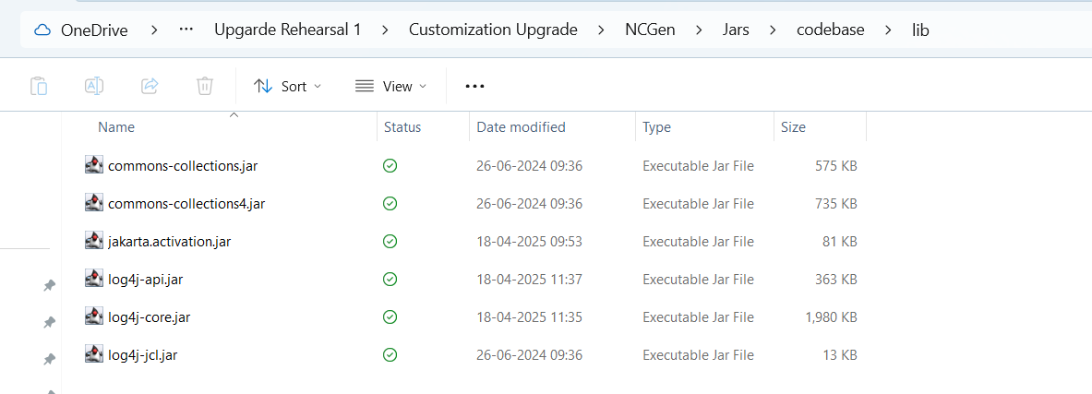
- <WC_HOME>codebase\WEB-INF\lib
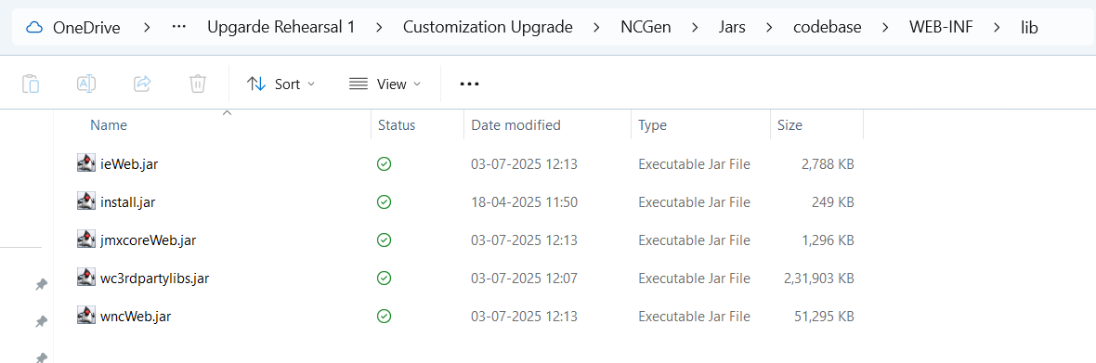
- <WC_HOME>codebase
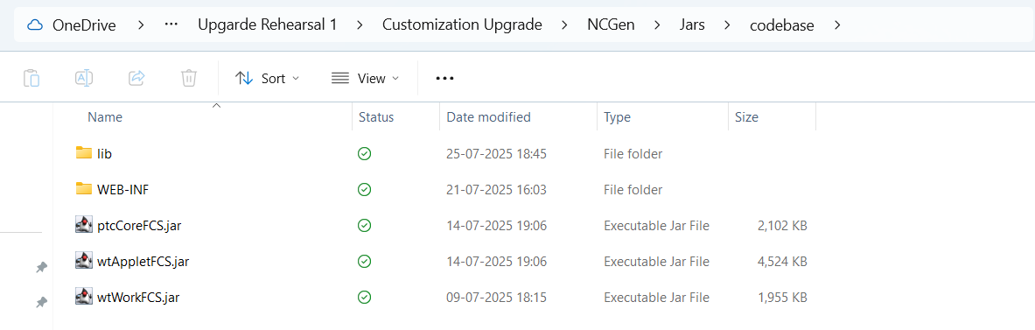
- <WC_HOME>\srclib\wnc
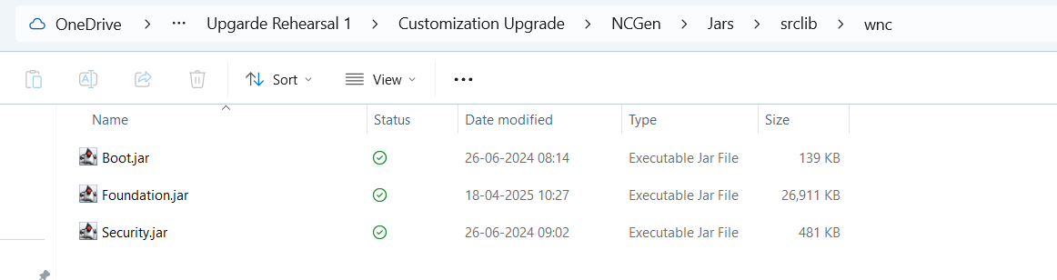
- <WC_HOME>\srclib
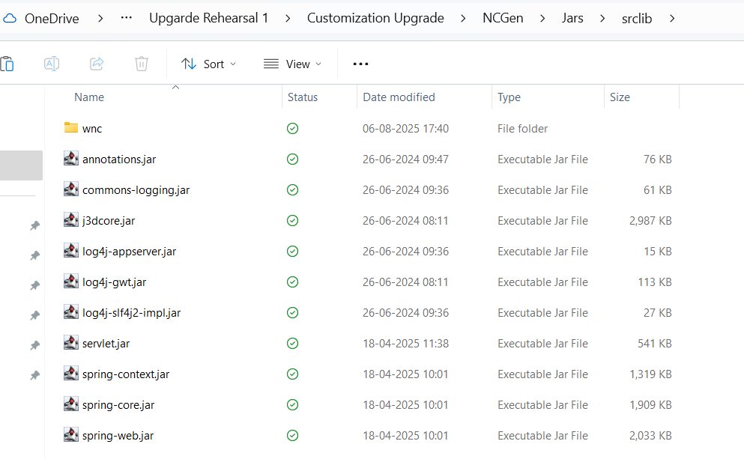

Custom Properties file
- Copy below all .properties from
<WC_HOME> \codebase\schindlerProperties
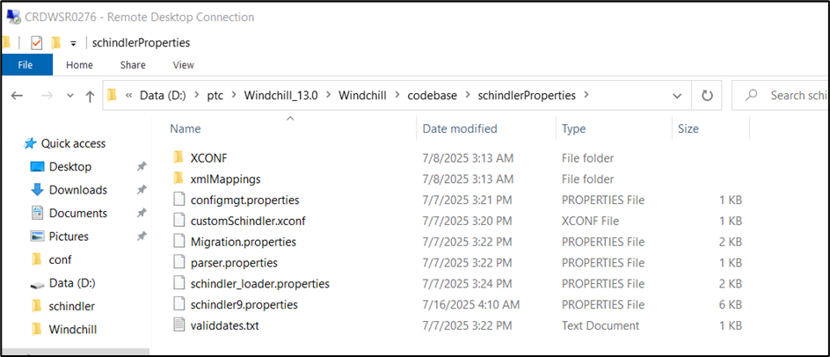
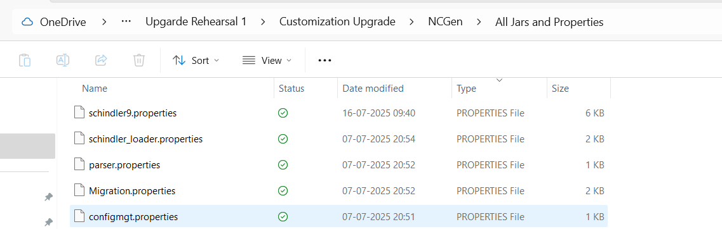

Custom Jar creation

Input file for jar
- Download attached build_ptcms_jar.xml, build_wt_jar.xml and build_wt_properties.xml files
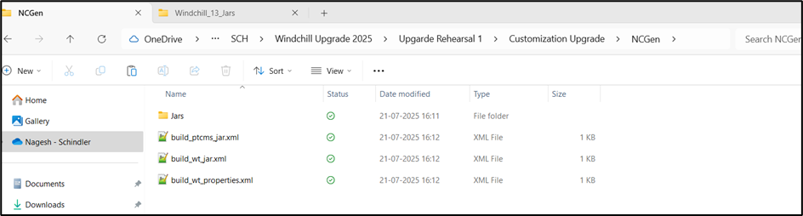
- Copy these three xmls to server under <WC_HOME>
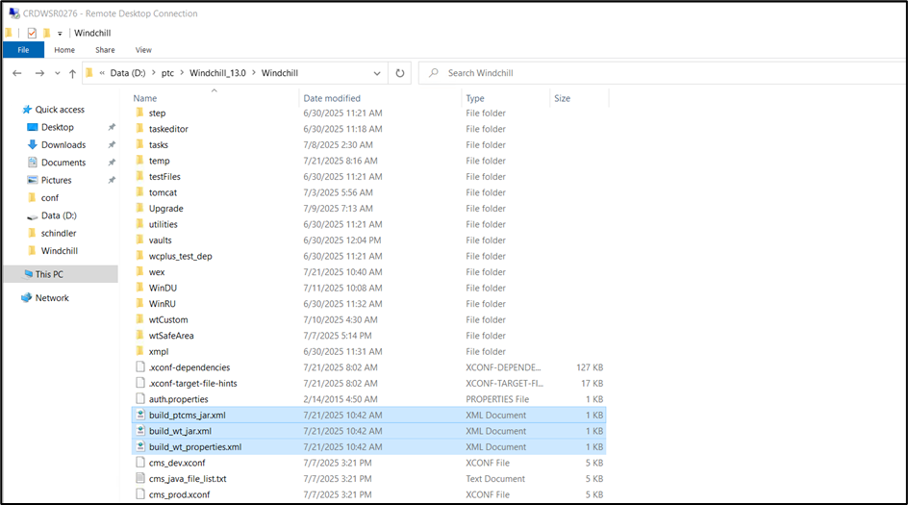

wt.jar Creation
- Open build_wt_jar.xml and update WT_HOME and OUT_DIR properties as per below snapshot
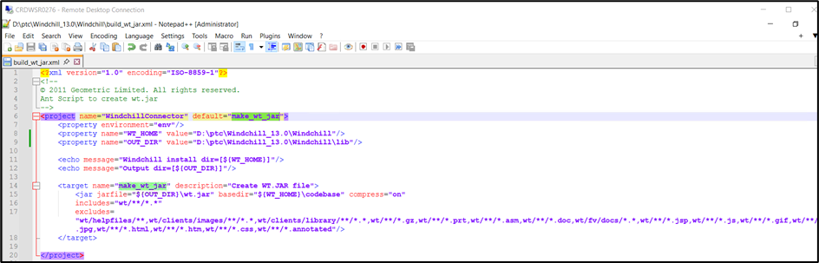
- Open Windchill Shell and run below command
ant -f "D:\ptc\Windchill_13.0\Windchill\build_wt_jar.xml" make_wt_jar
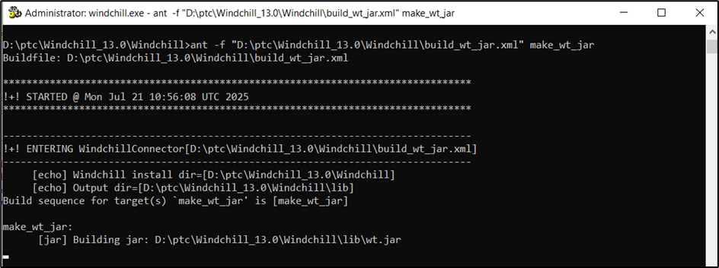
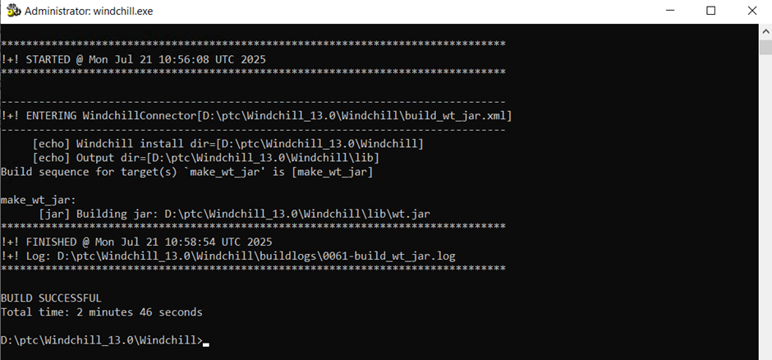
- Make sure wt.jar is created in <WC_HOME>\lib
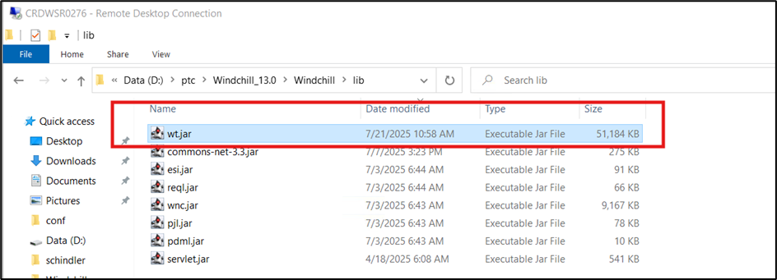
- Copy wt.jar to local folder
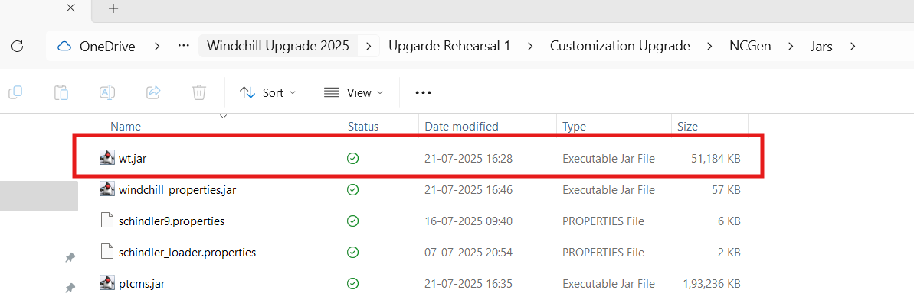

ptcms.jar Creation
- Open build_ptcms_jar.xml and update WT_HOME and OUT_DIR properties as per below snapshot
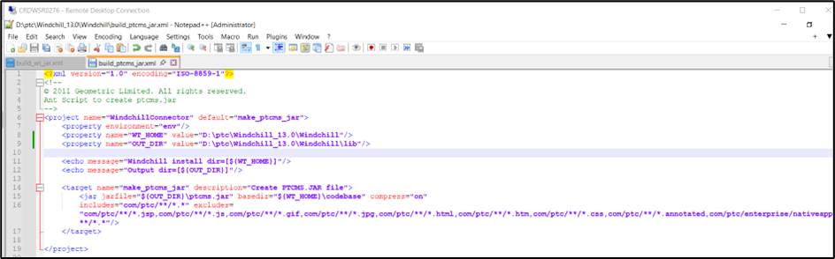
- Open Windchill Shell and run below command
ant -f "D:\ptc\Windchill_13.0\Windchill\build_ptcms_jar.xml" make_ptcms_jar
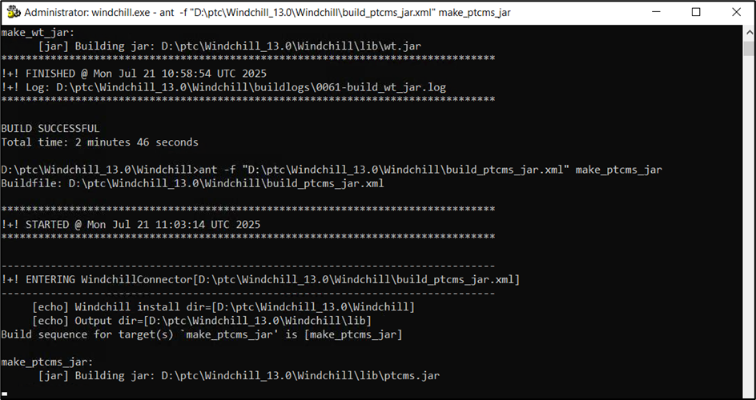
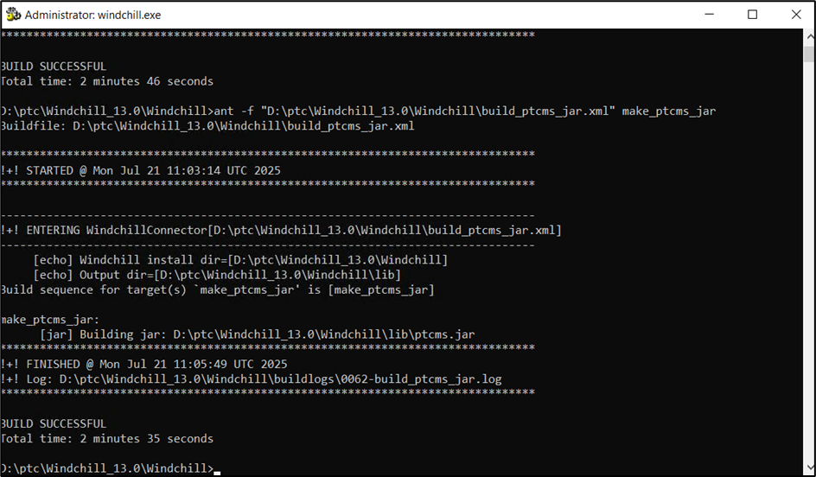
- Make sure ptcms.jar is created in <WC_HOME>\lib
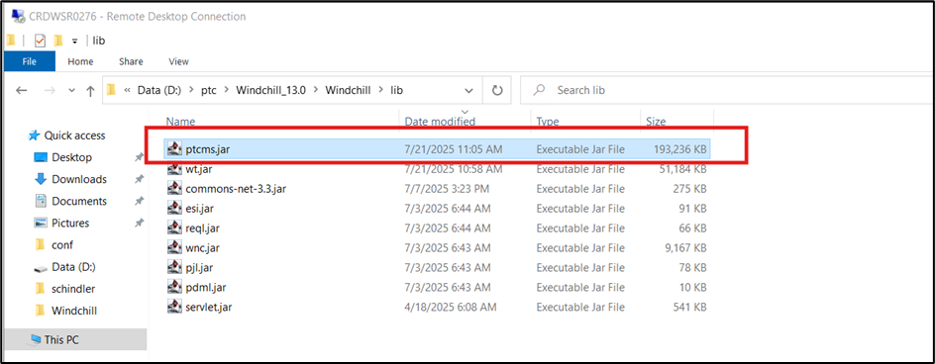
- Copy ptcms.jar to local folder
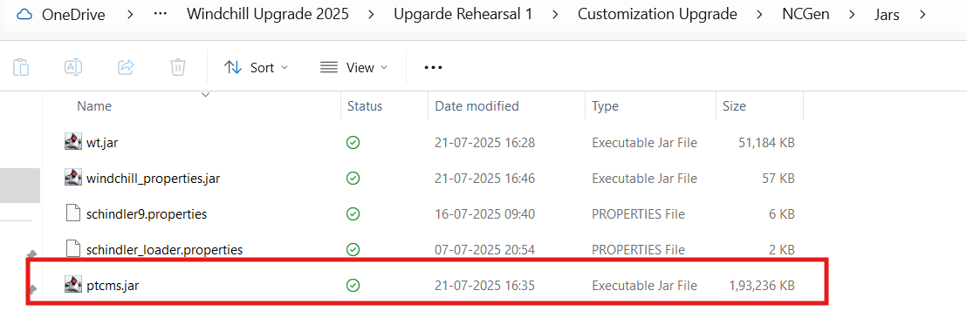

windchill_properties.jar Creation
- Open build_wt_properties.xml and update WT_HOME and OUT_DIR properties as per below snapshot
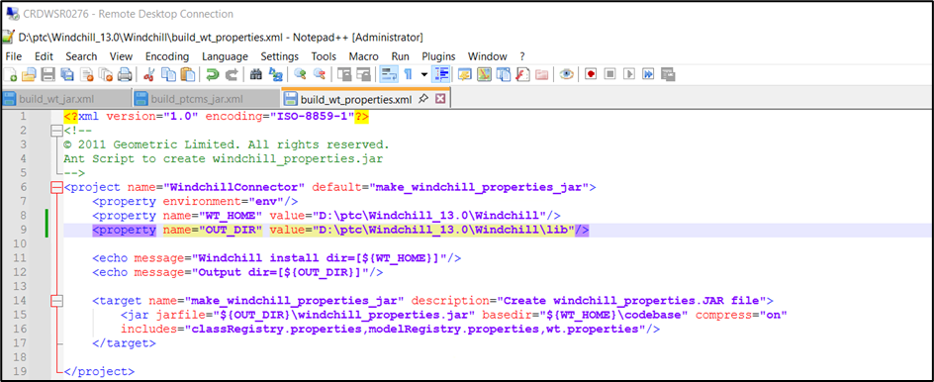
- Open Windchill Shell and run below command
ant -f "D:\ptc\Windchill_13.0\Windchill\build_wt_properties.xml" make_windchill_properties_jar
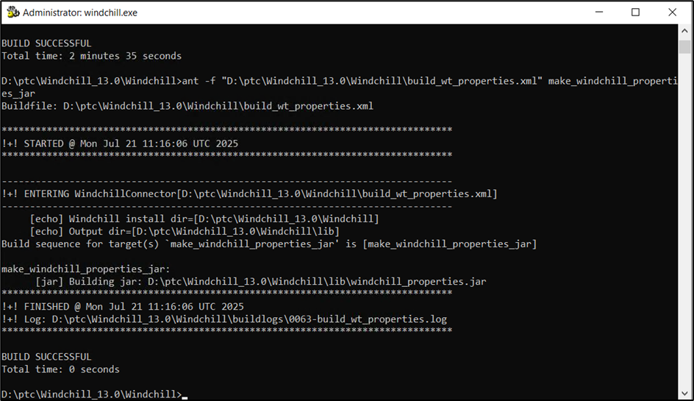
- Make sure windchill_properties.jar is created in <WC_HOME>\lib
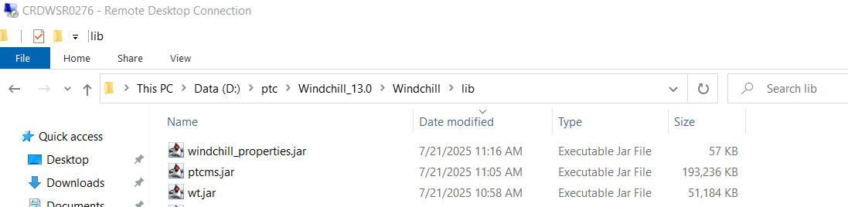
- Copy windchill_properties.jar to local folder
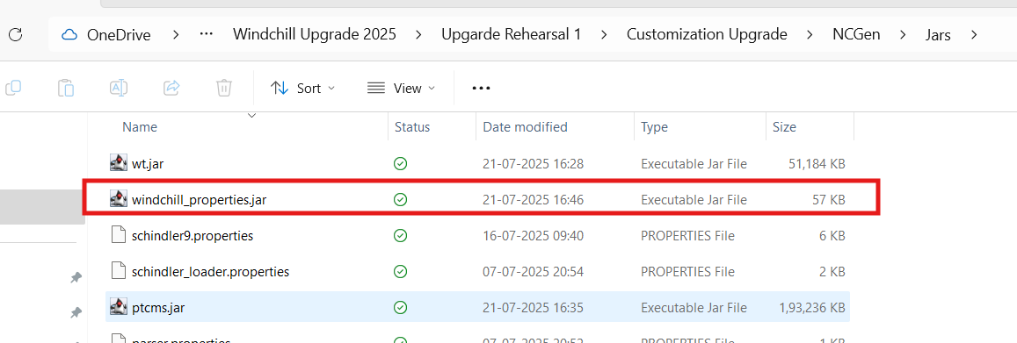

BAC.jar Creation
- Copy BAC.jar from <WC_HOME>\srclib\wnc to any temp location on local
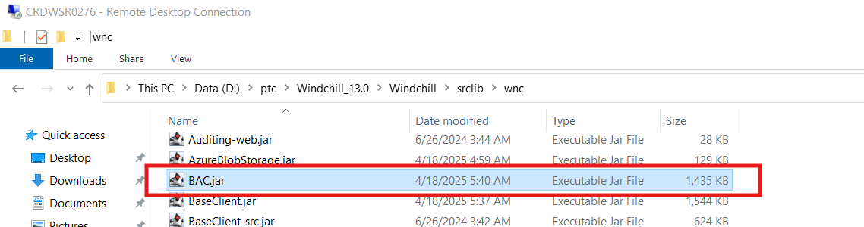
- Change the extension .jar to .zip and extract the zip
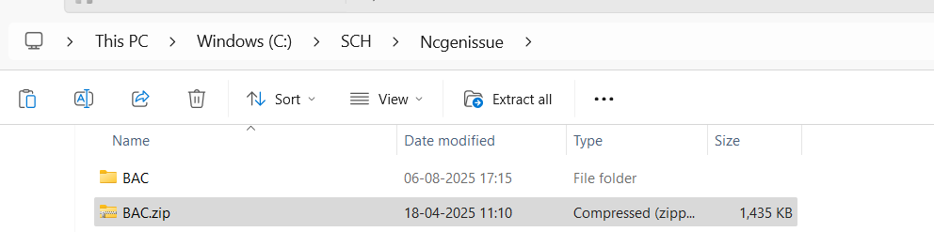
- Copy D:\ptc\Windchill_13.0\Windchill\codebase\wt\businessRules\bac folder to wt\businessrules location in extracted zip
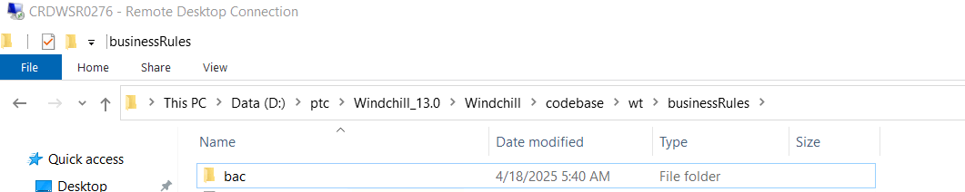
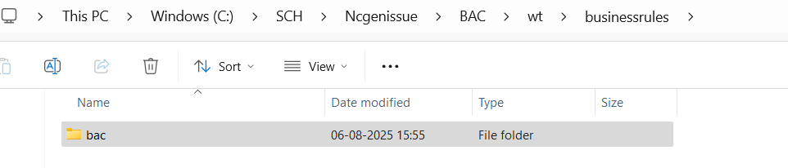
- Select below folder and create zip
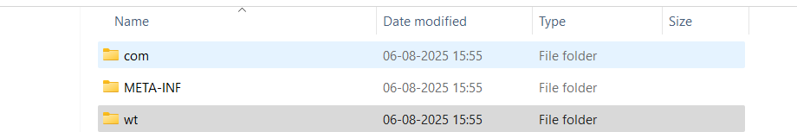
- Update .zip extension to .jar


SSL Certificate
- Copy server.crt and server.key from D:\ptc\Windchill_13.0\HTTPServer\conf to local folder
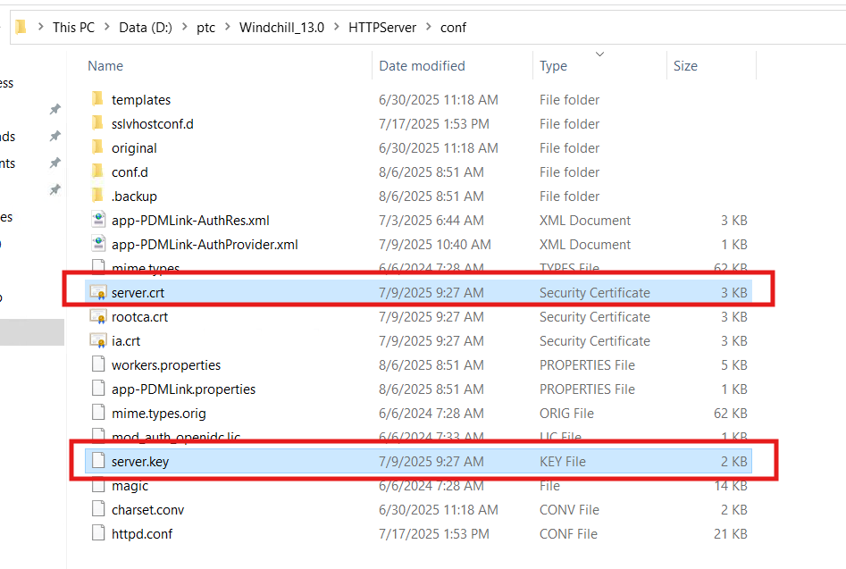
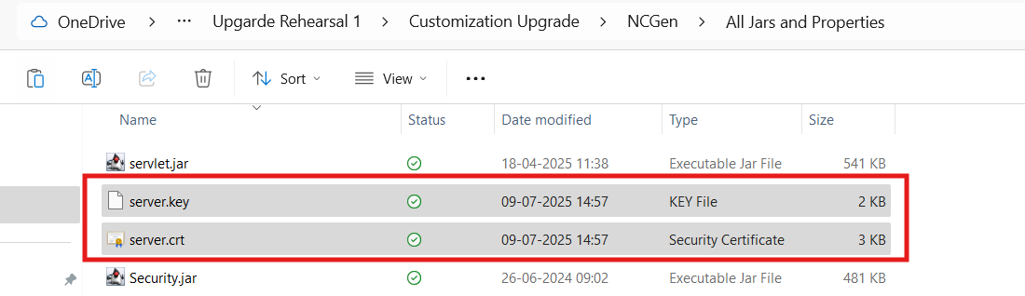

Share jar/Properties/Certificate with NCGen
- Create on single folder and place all jars and properties
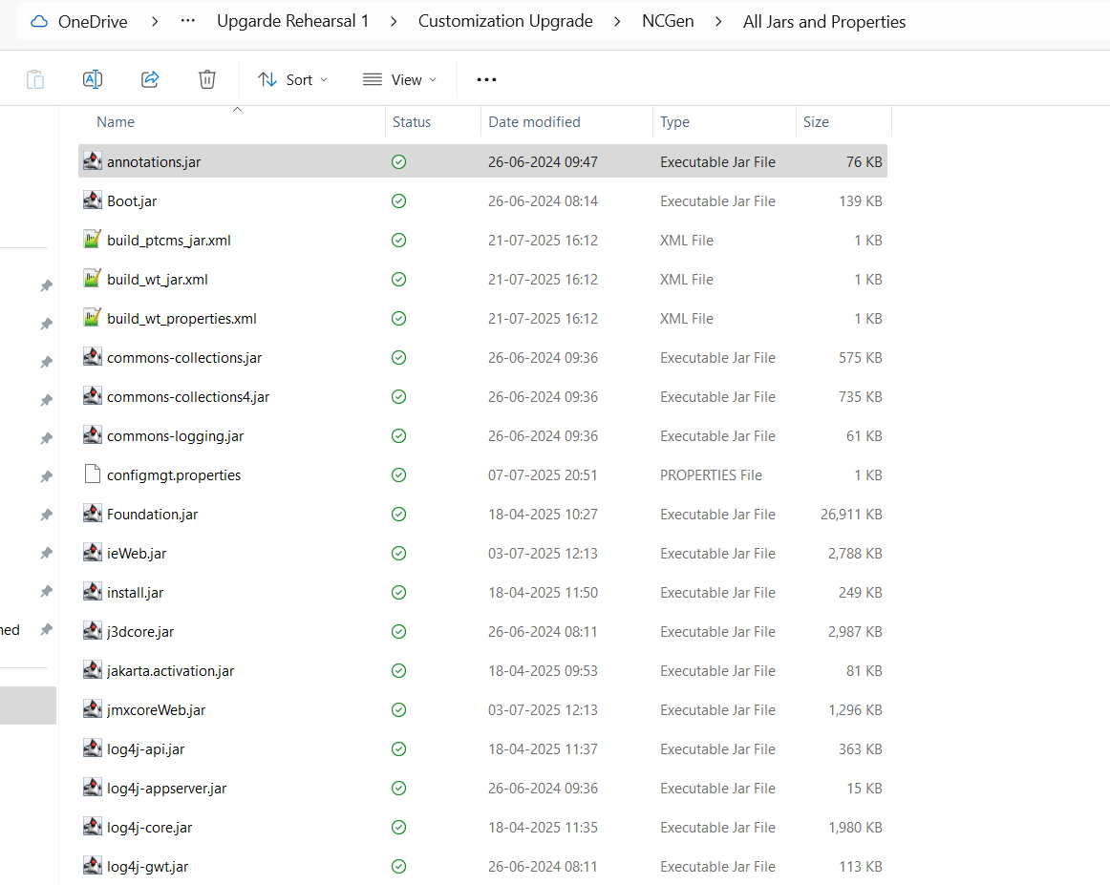
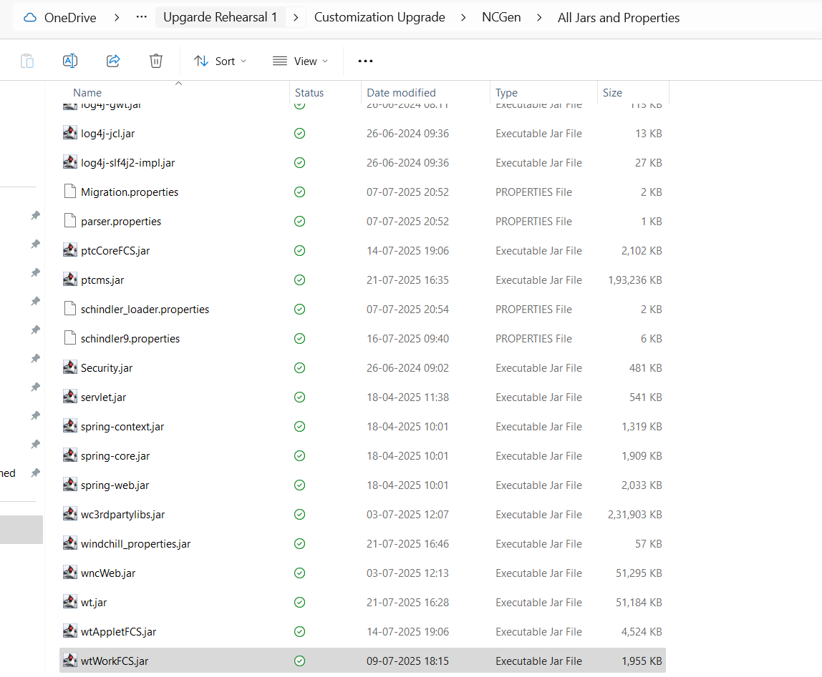
- Copy this folder to dswwsr0011 server as requested by NCGen team.
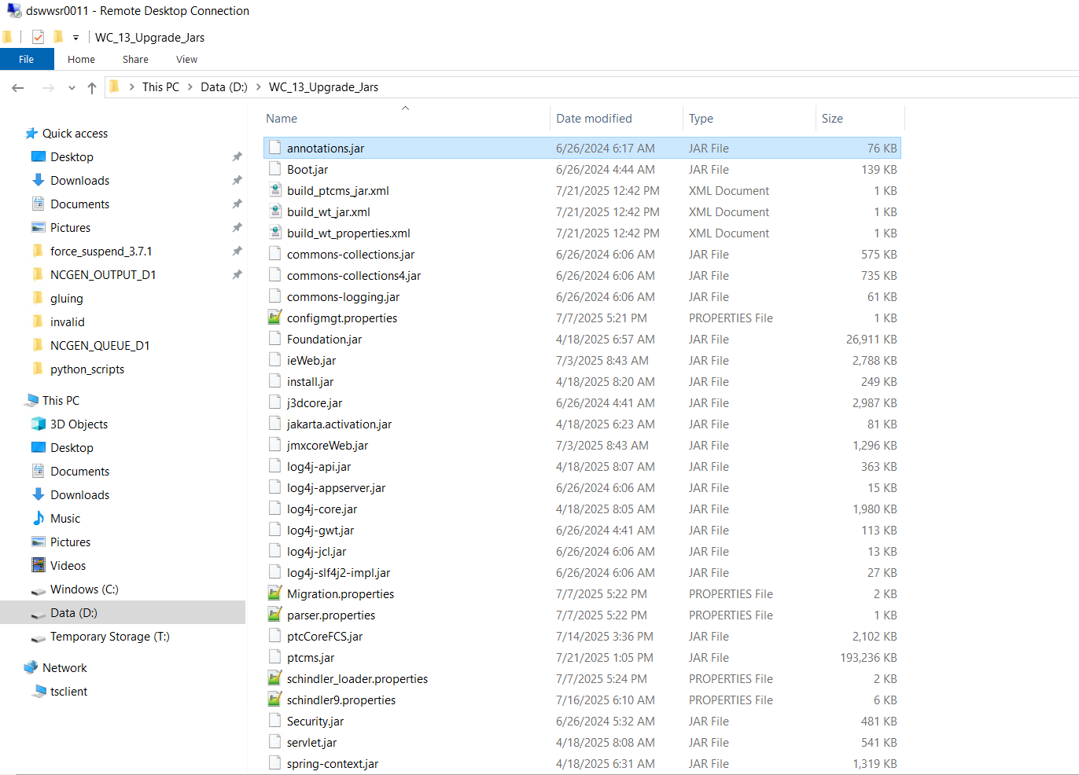
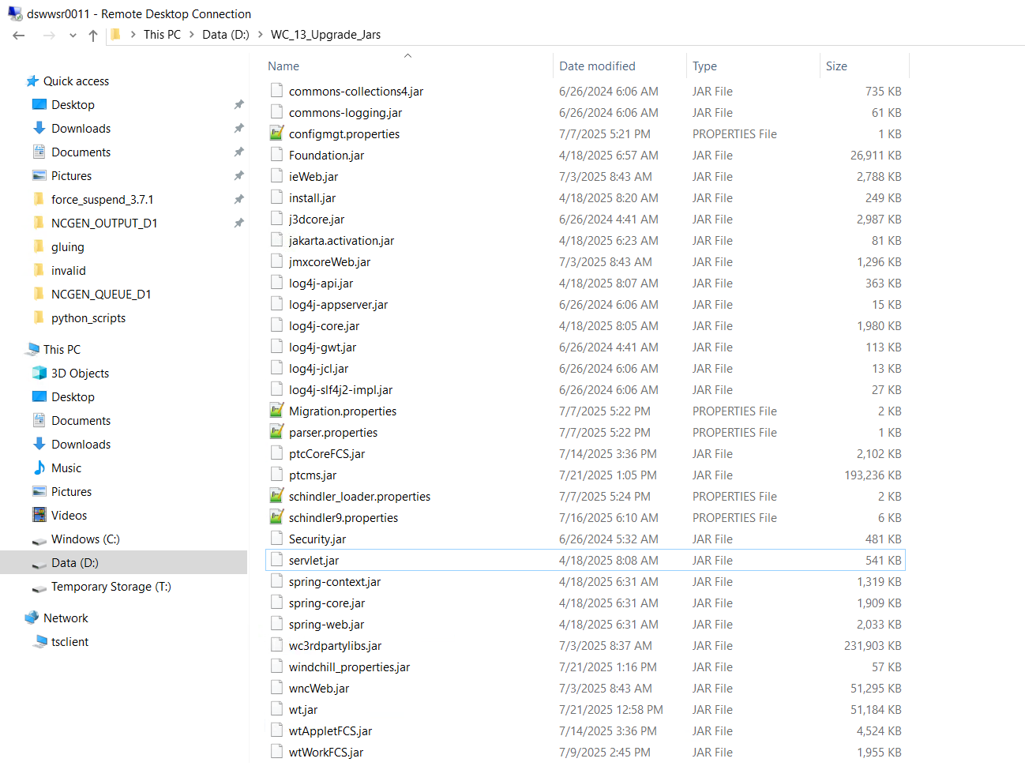

Issues and Resolution

RMI issue over HTTP tunneling is not supported with this Java version

Issue :
- Getting below error while build deployment on NcGen servers
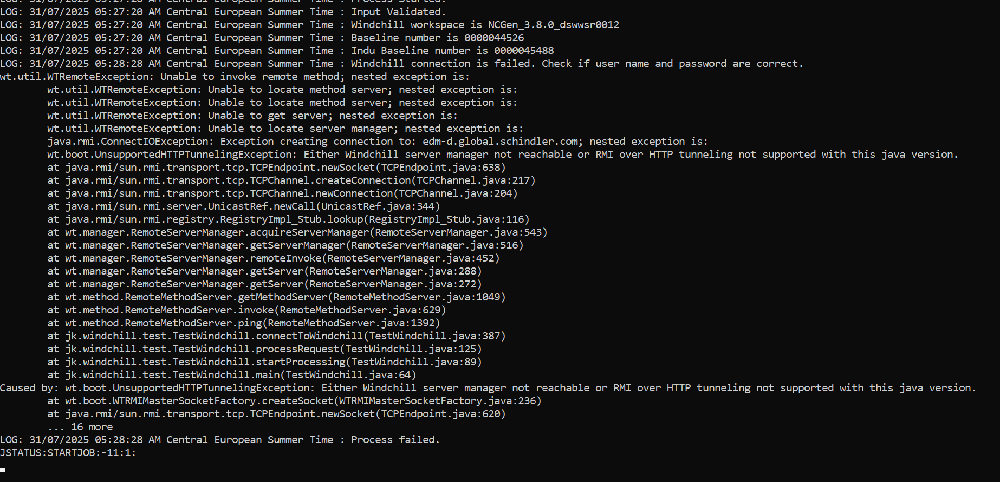

Resolution :
- This issue is because of Windchill application server SSL certificate is not imported on NcGen servers
- Share server.crt and server.key files from D:\ptc\Windchill_13.0\HTTPServer\conf folder with NcGen team.
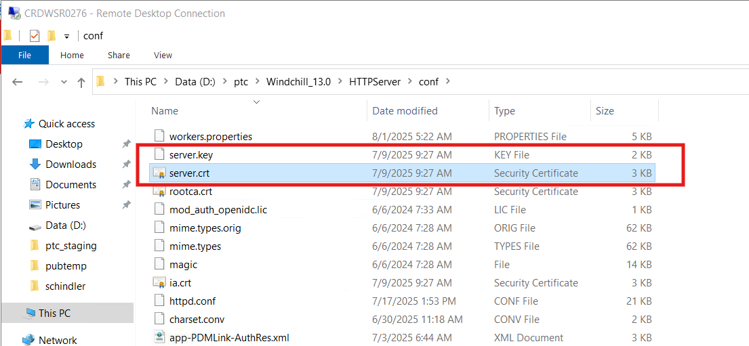

WhereExpression Class not found exception while package compilation

Issue :
- Getting below error while build deployment on NcGen servers
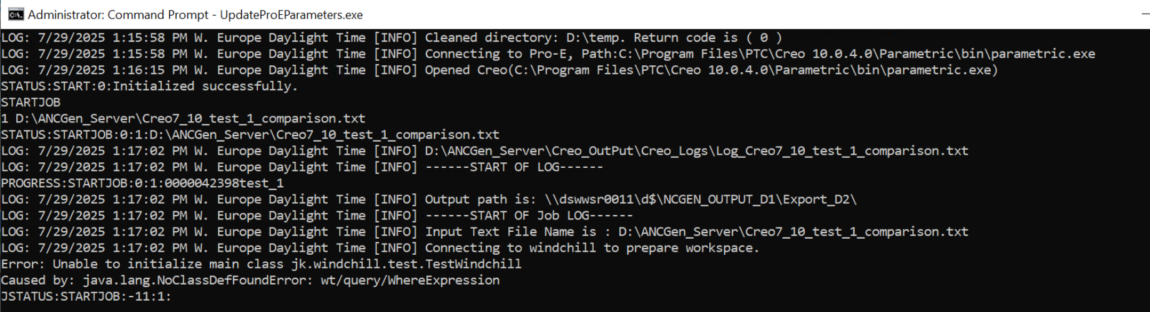

Resolution :
- Stop Apache and Windchill services on Windchill Application Server CRDWSR0276
- Recreate wt.jar as per wt.jar creation step in this document
- Share latest wt.jar with NcGen team.
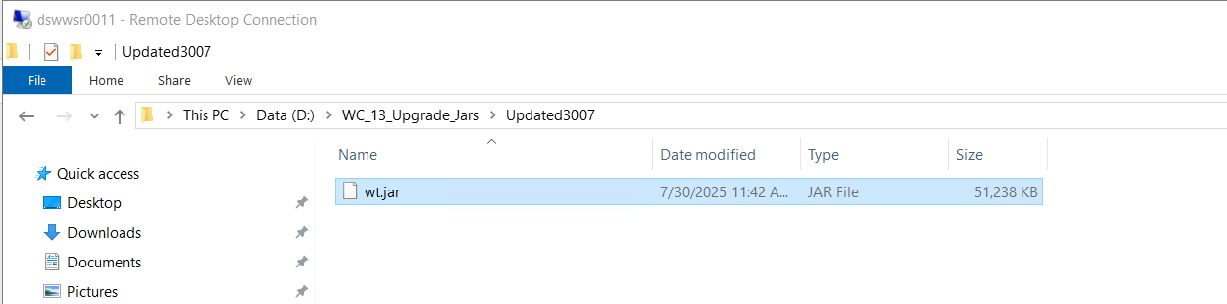

Getting Windchill Authentication pop-up while publishing jobs on NcGen Worker

Issue :
- Authentication pop-up is shown while publishing job from cmd on NcGen worker machine
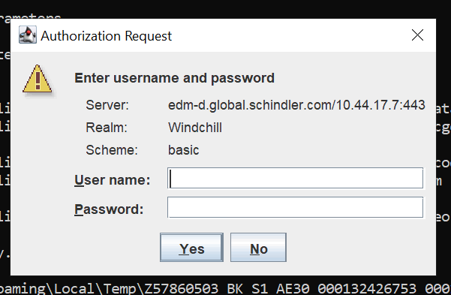

Resolution :
- <TBD>

